**JIRA SOFTWARE ACCOUNT**

##### ROAD MAP:

A roadmap is a strategic plan that deﬁnes a goal or desired outcome and includes the major steps or milestones needed to reach it. It also serves as a communication tool, a high-level document that helps articulate strategic thinking—thewhy—behind both the goal and the plan for getting there.

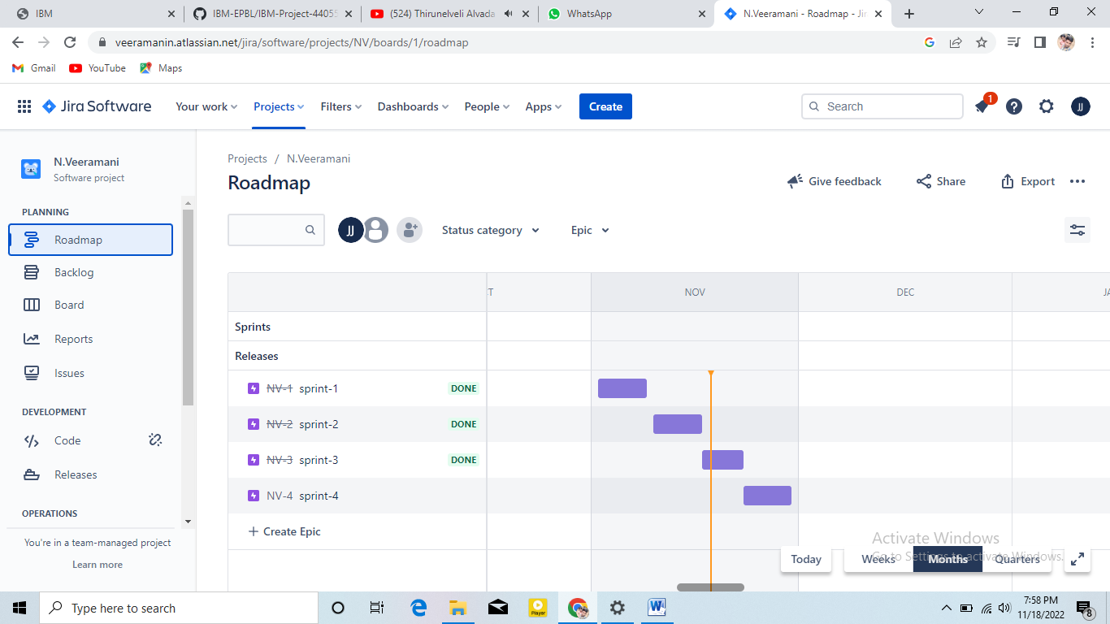

**PROJECT ACCESS:**

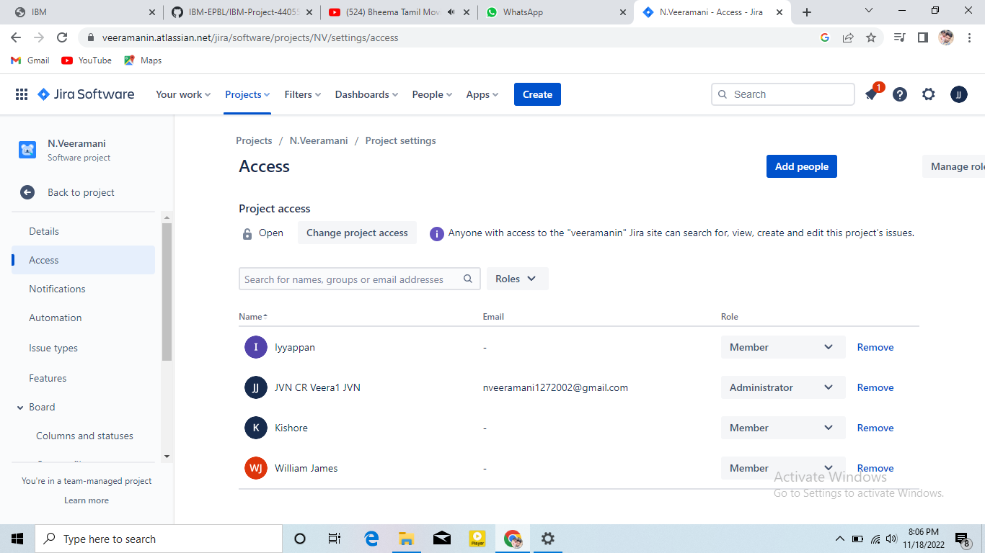

PROJECT ISSUES:

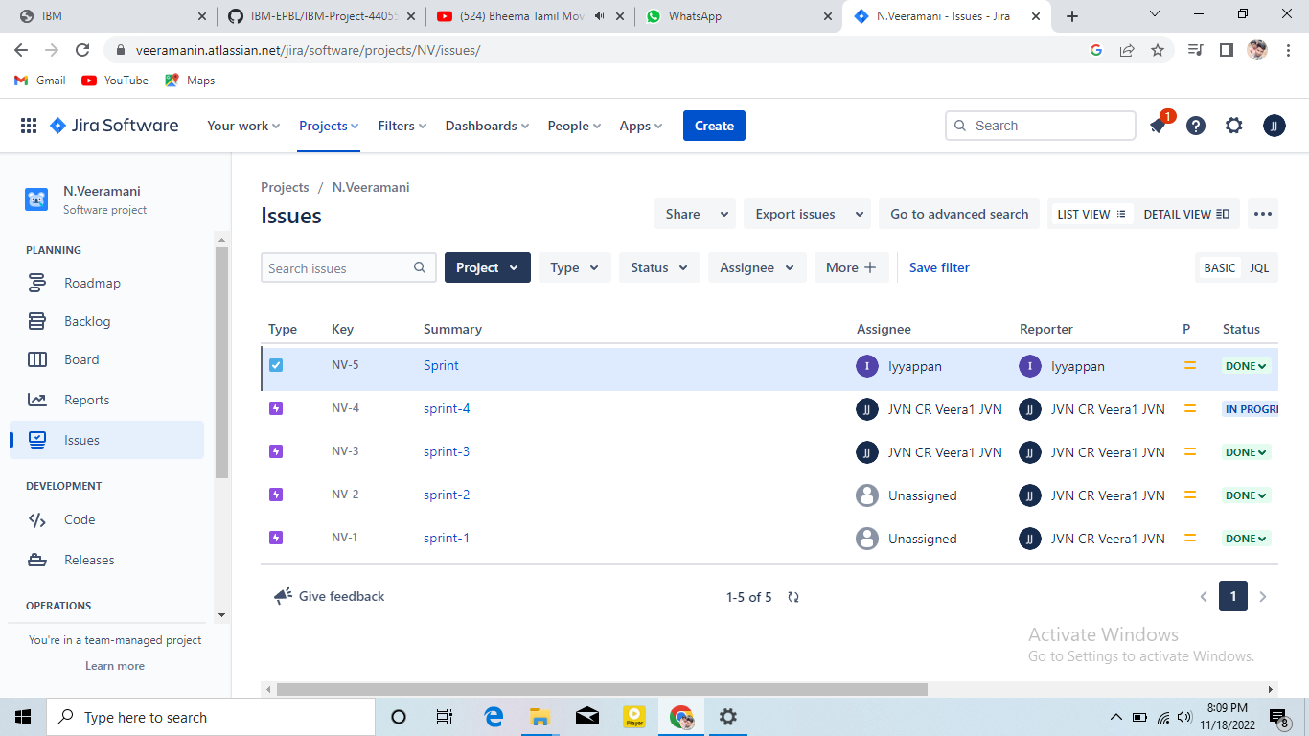

**JIRA SOFTWARE LINK:**

https://veeramanin.atlassian.net/jira/projects?selectedProjectType=software